

Internal EHSMS Audit System

Internship Project



DHVANI GOLANI

PRN: 2018033800104805

Internship No.: I16

Guided By: Mrs. Palak Panchal

Table of Contents

Internship Certificate 2

Introduction 3

Scope 3

Contents 4

Site Flow 5

Login Page 6

Audit Form [ PART-A ] 7

HSE Surveillance [ PART-B ] 13

Non-Conformance Report(NC Report) [ PART-C ] 16

Audit Details 21

Dashboard 27

## Internship Certificate

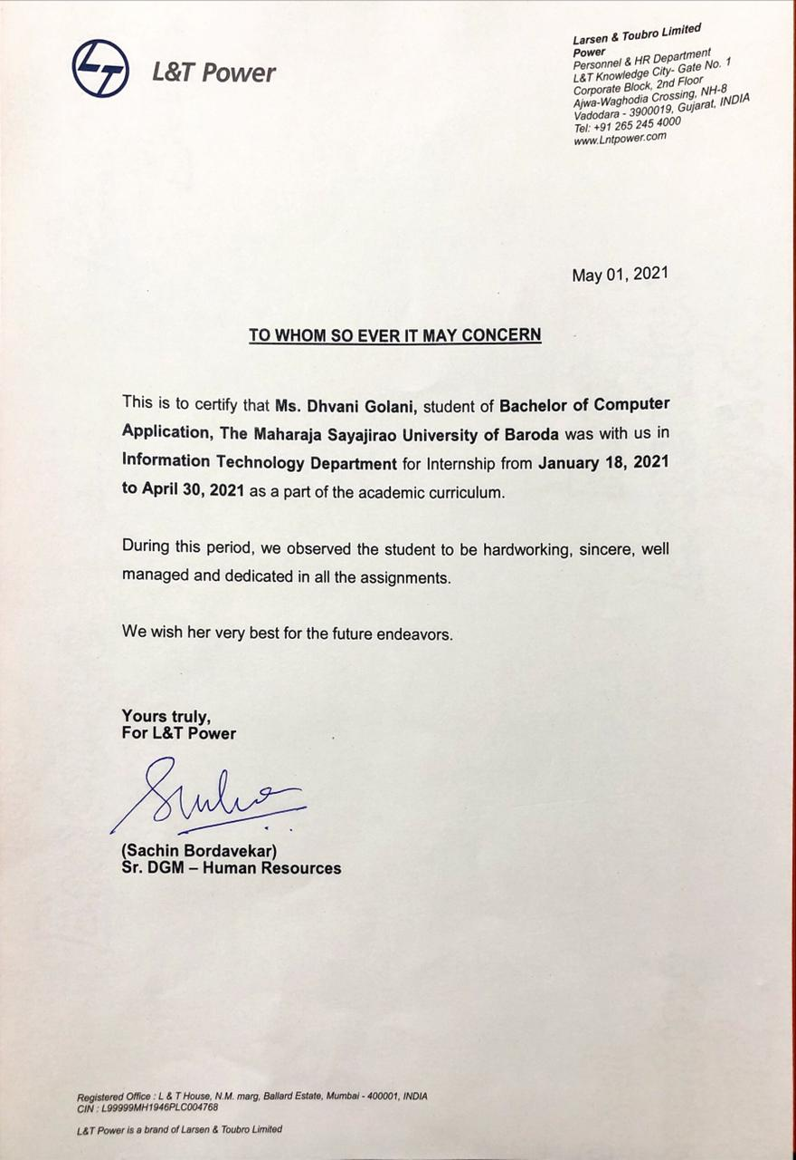

## **Introduction**

EHSMS Audit System

An environmental health and safety (EHS) audit are a systematic, objective tool to assess regulatory compliance in the workplace. An audit usually involves a survey of the workplace to:

* Identify what regulations apply to the facility.
* Determine whether workers are adhering to environmental and workplace safety requirements or other corporate policies and procedures regarding compliance.
* Assess methods used and systems currently in place to ensure compliance.
* The role of internal audit system is to provide independent assurance that an organization's risk management, governance and internal control processes are operating effectively.
* This type of software is used to define, implement, and monitor auditing procedures.

## **Scope**

* + Streamline EHS audits to reduce errors and increase accuracy of data capture.
  + Automate audit planning, scheduling and alerts so you can plan and respond effectively.
  + Reduce documentation and inaccuracies with a centralized, auditable system.
  + Deliver custom reports and dashboards to track auditing.
  + Integrate tracking and monitoring of permits and regulatory documents.



**NOTE:**

*An environmental health and safety (EHS) audit are a systematic, objective tool to assess regulatory compliance in the workplace. An audit usually involves a survey of the workplace to:*

* *Identify what regulations apply to the facility.*
* *Determine whether workers are adhering to environmental and workplace safety requirements or other corporate policies and procedures regarding compliance.*
* *Assess methods used and systems currently in place to ensure compliance.*

## Contents

## Site Flow

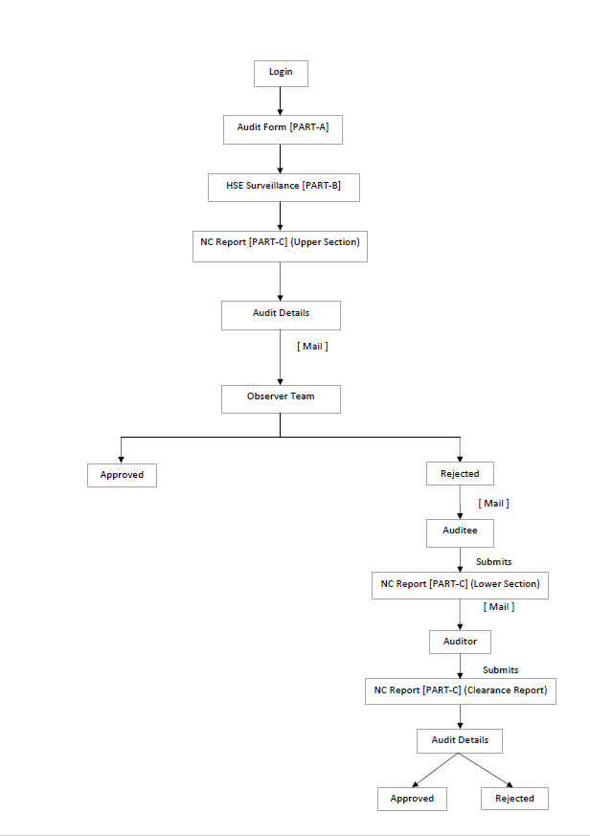

## **Login Page**

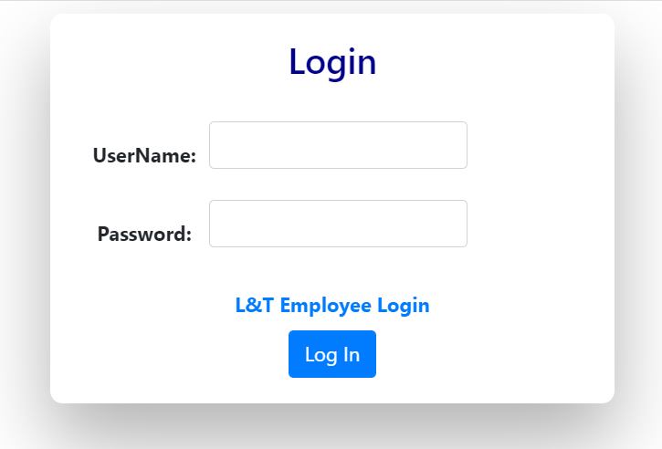

* Enter your correct username and password and click the Login Button.
* On Successful login the page is redirected to the Audit Form [PART-A].
* Both the fields are required.

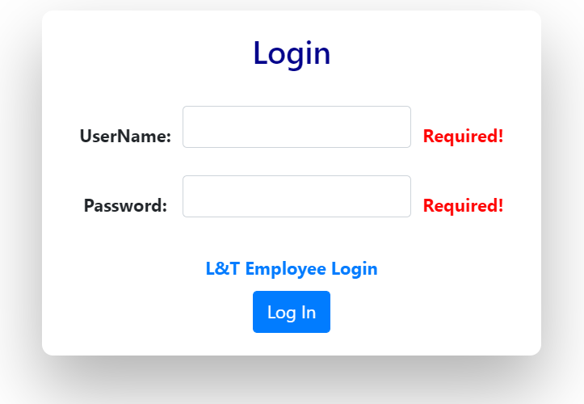 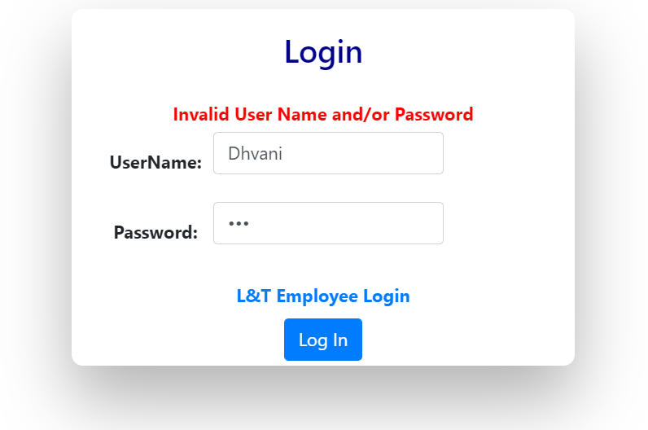

## **Audit Form [ PART-A ]**

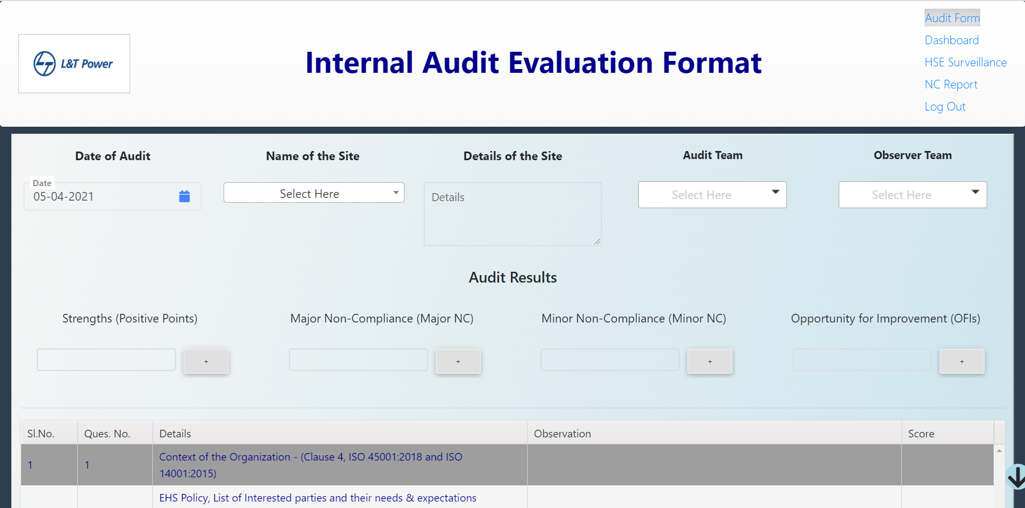

* **Contents of Audit Form**

1. **Date of Audit**

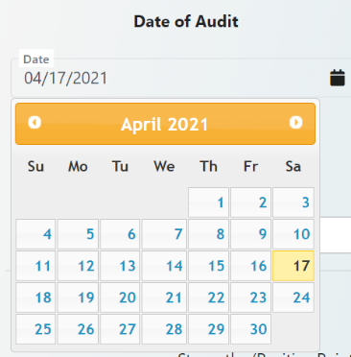

* The Date of Audit is selected here through the date picker.
* The default Date is set to current date.

1. **Name of Site**

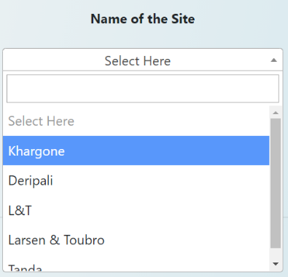 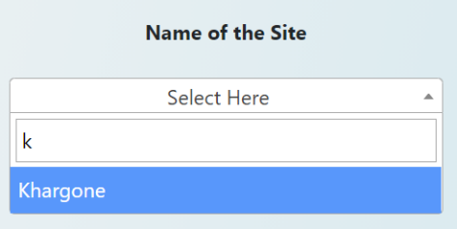

* Name of Site is chosen through the dropdown and the search bar provided in it.
* This field is also compulsory as on basis of selection of this field, the audit and observer team’s dropdown are populated.

1. **Details of the Site**

* In this text area, the details about the site of audit are to be filled.
* This field is essential.

1. **Audit Team**

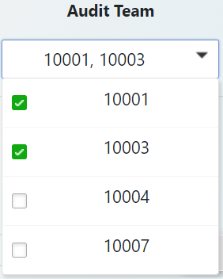

* The Audit Team dropdown consists of PS No. of people in the auditing team for that particular site.
* As it is a multiselect dropdown, multiple people can be chosen.
* This is a necessary field.

1. **Observer Team**

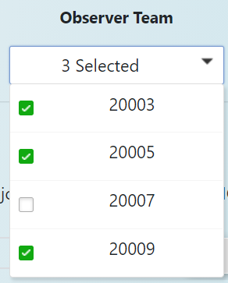

* The Observer Team dropdown consists of PS No. of people in the observing team for that particular site.
* As it is a multiselect dropdown, multiple people can be chosen.
* This is a mandatory field.

1. **Audit Results Section**

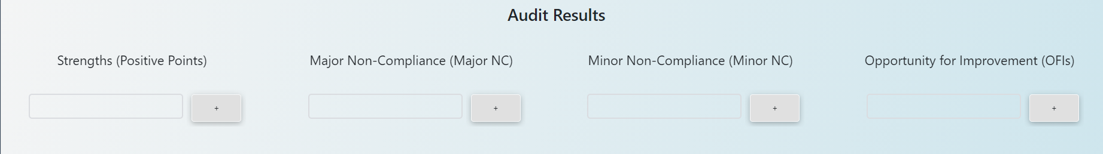

* This section consists of four compulsory fields which are as follows:

|  |  |
| --- | --- |
| 1. Strengths |  |
| 1. Major Non-Compliance |
| 1. Minor Non-Compliance |
| 1. Opportunity for Improvement |

* All the four fields have an add button for inserting more data. Also, a removing button is provided in case of extra fields created.
* All the four fields have at least one input required.

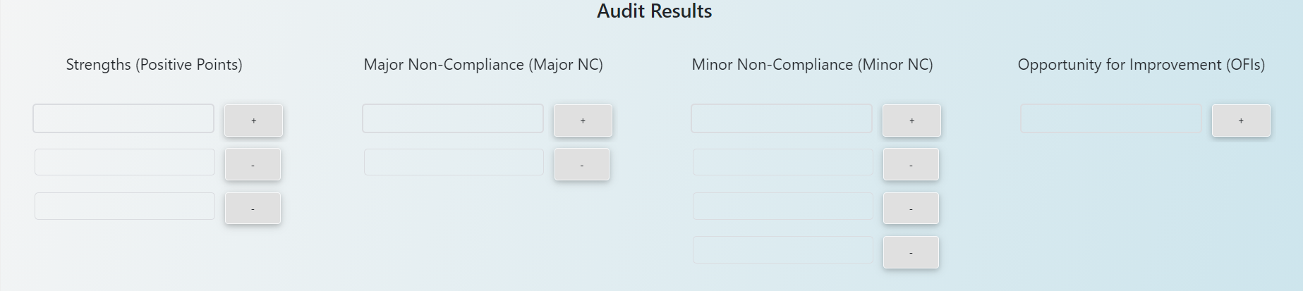

1. **Audit Observations / Evaluation**

* All the Observations and Scores are recorded here in this section.
* All the fields are required and the Scores may range from 0 to 2, 0 being the lowest and 2 being the highest.

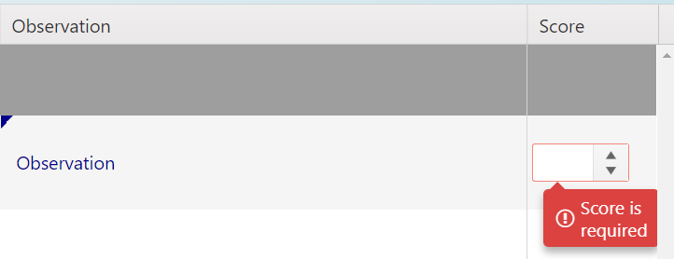

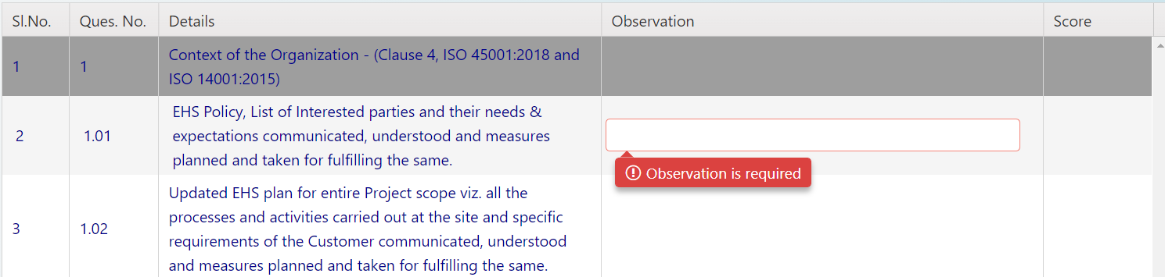

1. **Submission of Form**

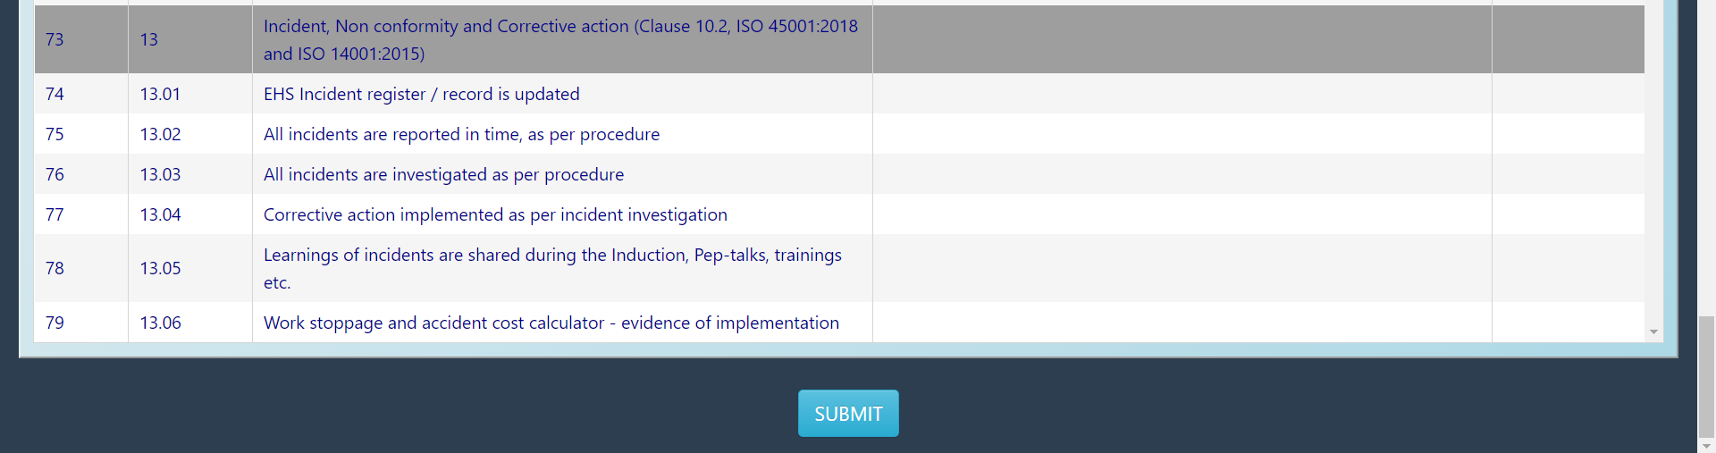

* After filling all the details, click submit button.
* If any of the details are missing in the form and are necessary to be filled then a short message is displayed.

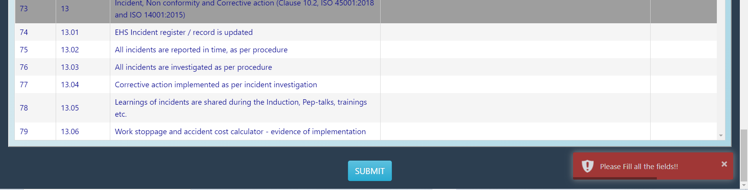

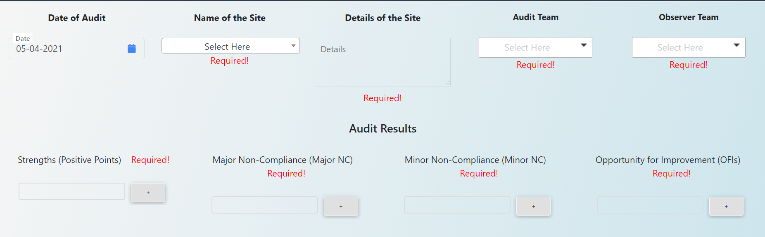

* On successful submission of form, a pdf of all the details entered here in the form is generated and sent as email to the email id of people selected in audit team and observer team and an alert kind of box is shown with “Successfully submitted!” message.

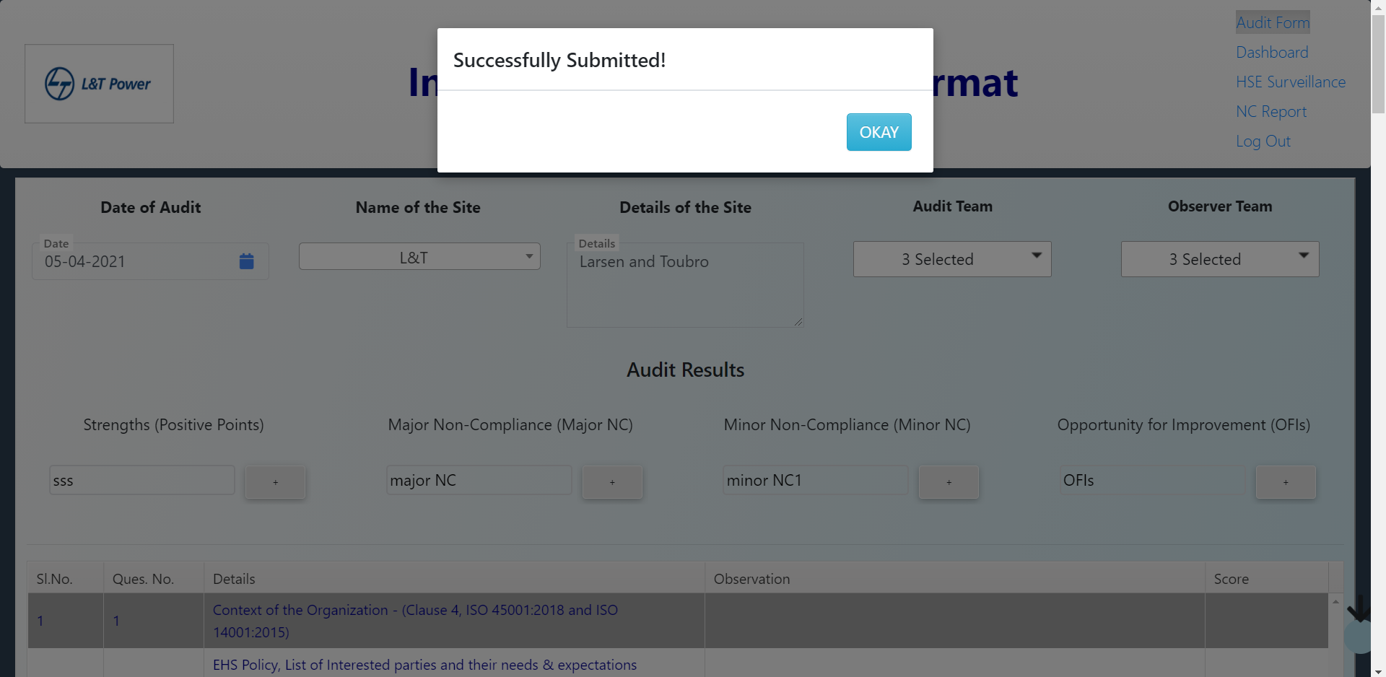

* Click okay to continue.
* After this, you are redirected to HSE Surveillance Form[PART-B].

## **HSE Surveillance [ PART-B ]**

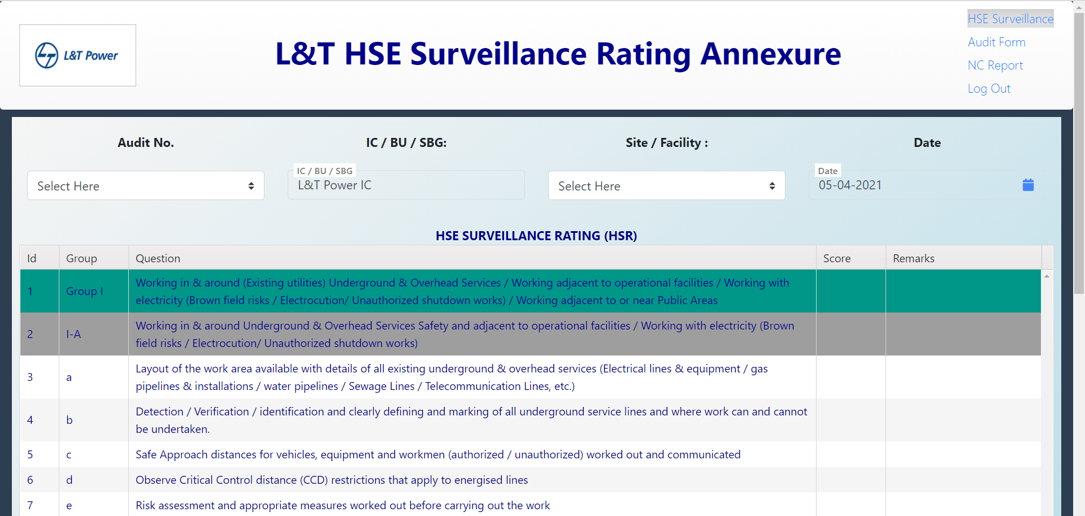

* **Contents of HSE Surveillance Form**

1. **Audit No.**

* Audit No. is generated on submission of Audit Form[PART-A], and it consists of Sitename/Year of Audit/ID.
* On selection of this, Site dropdown is automatically populated.
* This is a required field.

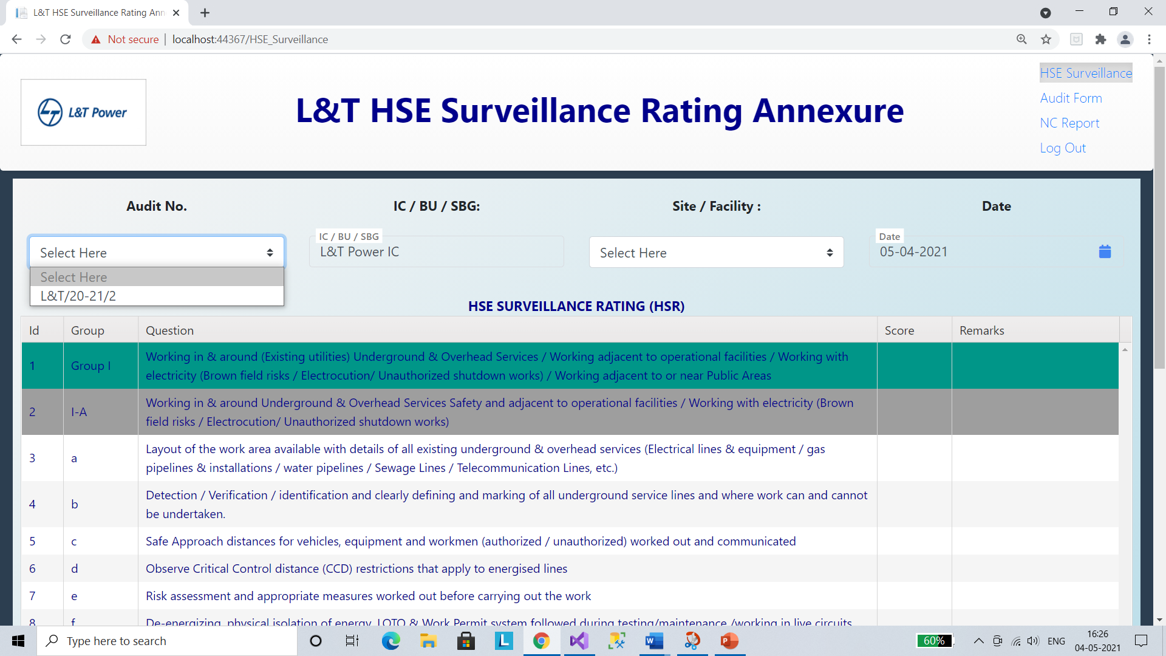

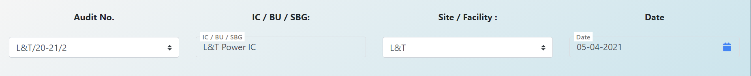

1. **IC / BU / SBG**

* This field is already set to “L&T Power IC”.

1. **Site / Facility**

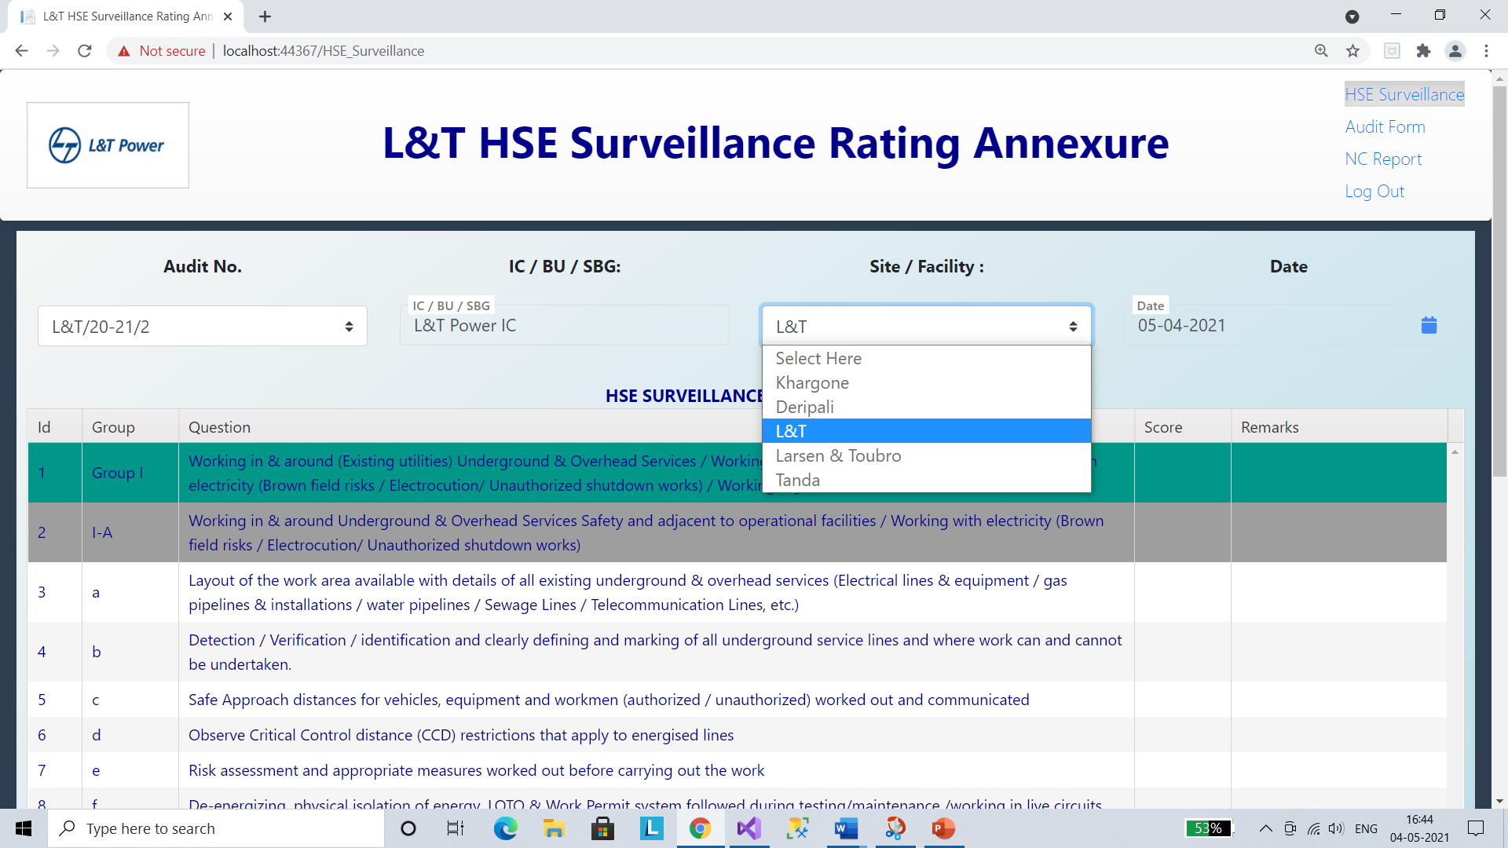

* Site dropdown is automatically filled on selection of Audit No. and other options are disabled.

1. **Date**

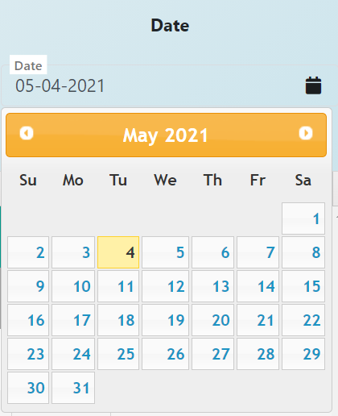

* The Date is selected here through the date picker.
* The default Date is set to current date.

1. **HSE Surveillance Rating**

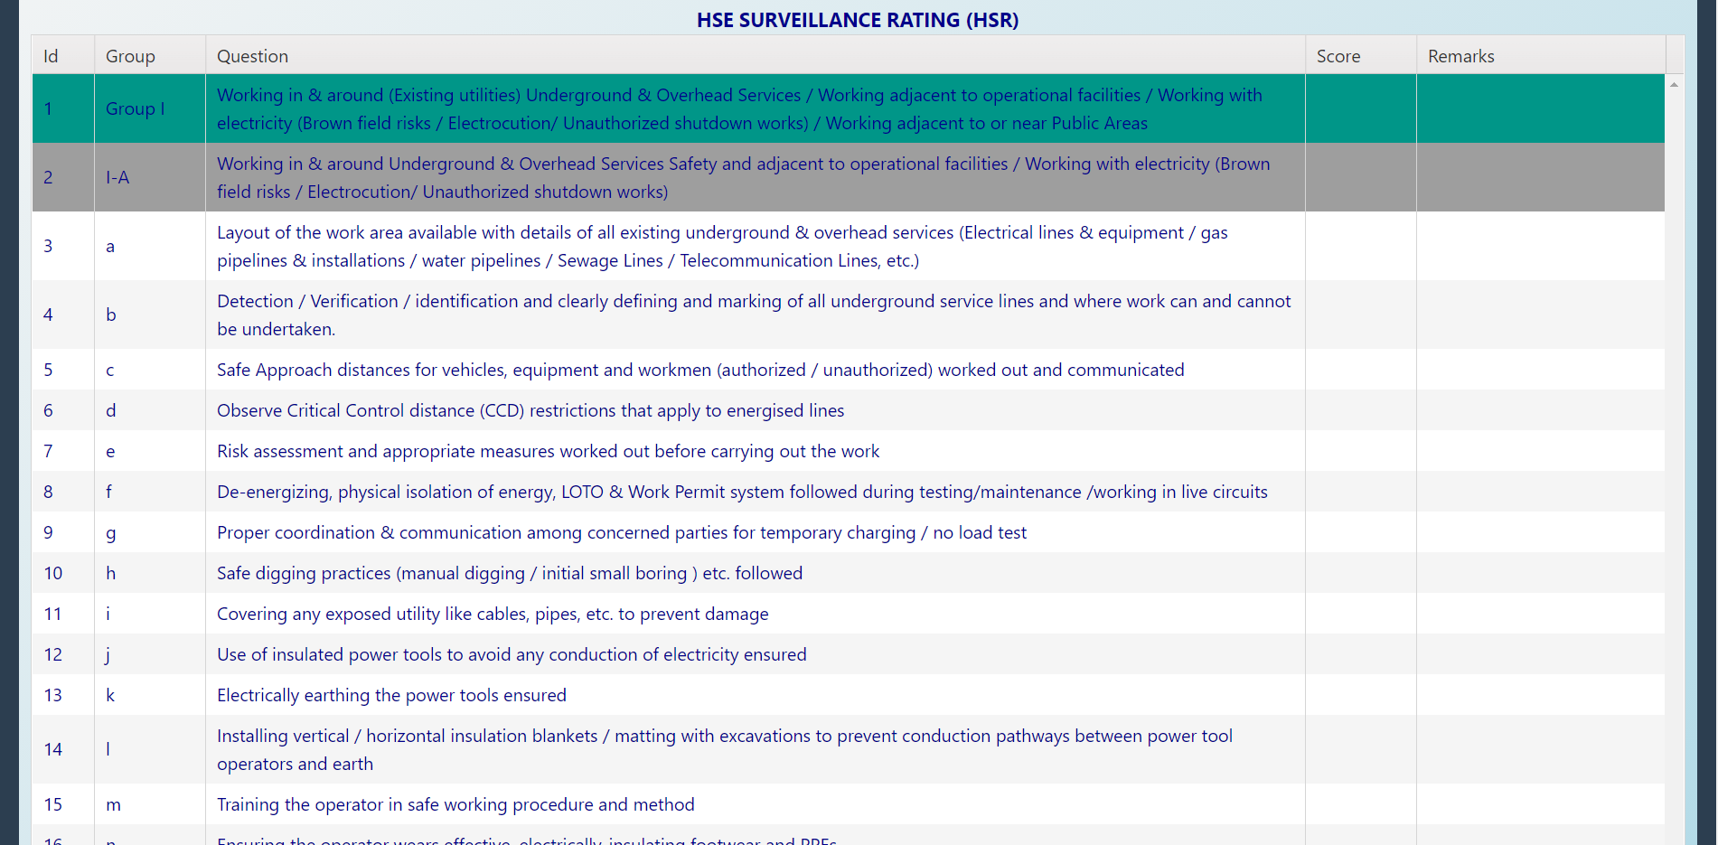

* In this section all the scores and remarks are entered by the Auditor.
* All the questions are mandatory.

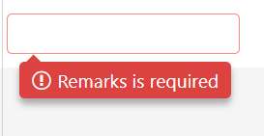  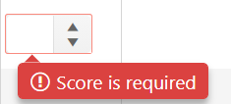

1. **Form Submission**

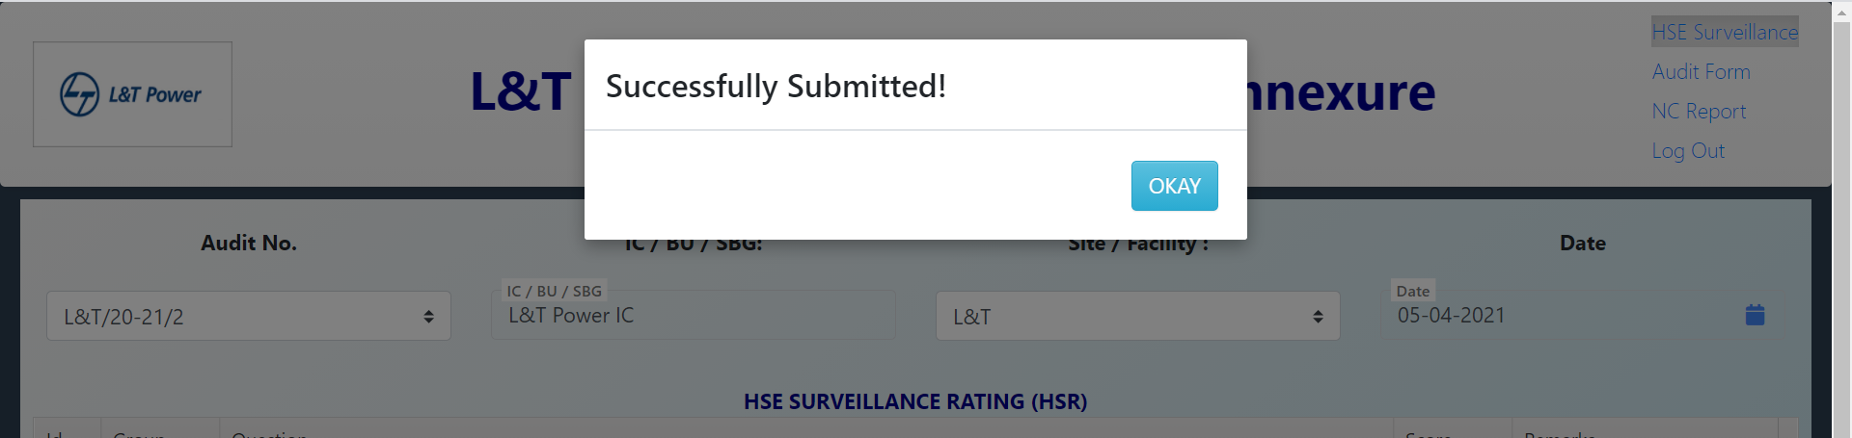

* When all the details are filled and form is submitted, a pop-up is shown and by clicking ‘Okay’ button of that pop-up the page is redirected to NC Report [ PART-C ].

## **Non-Conformance Report(NC Report) [ PART-C ]**

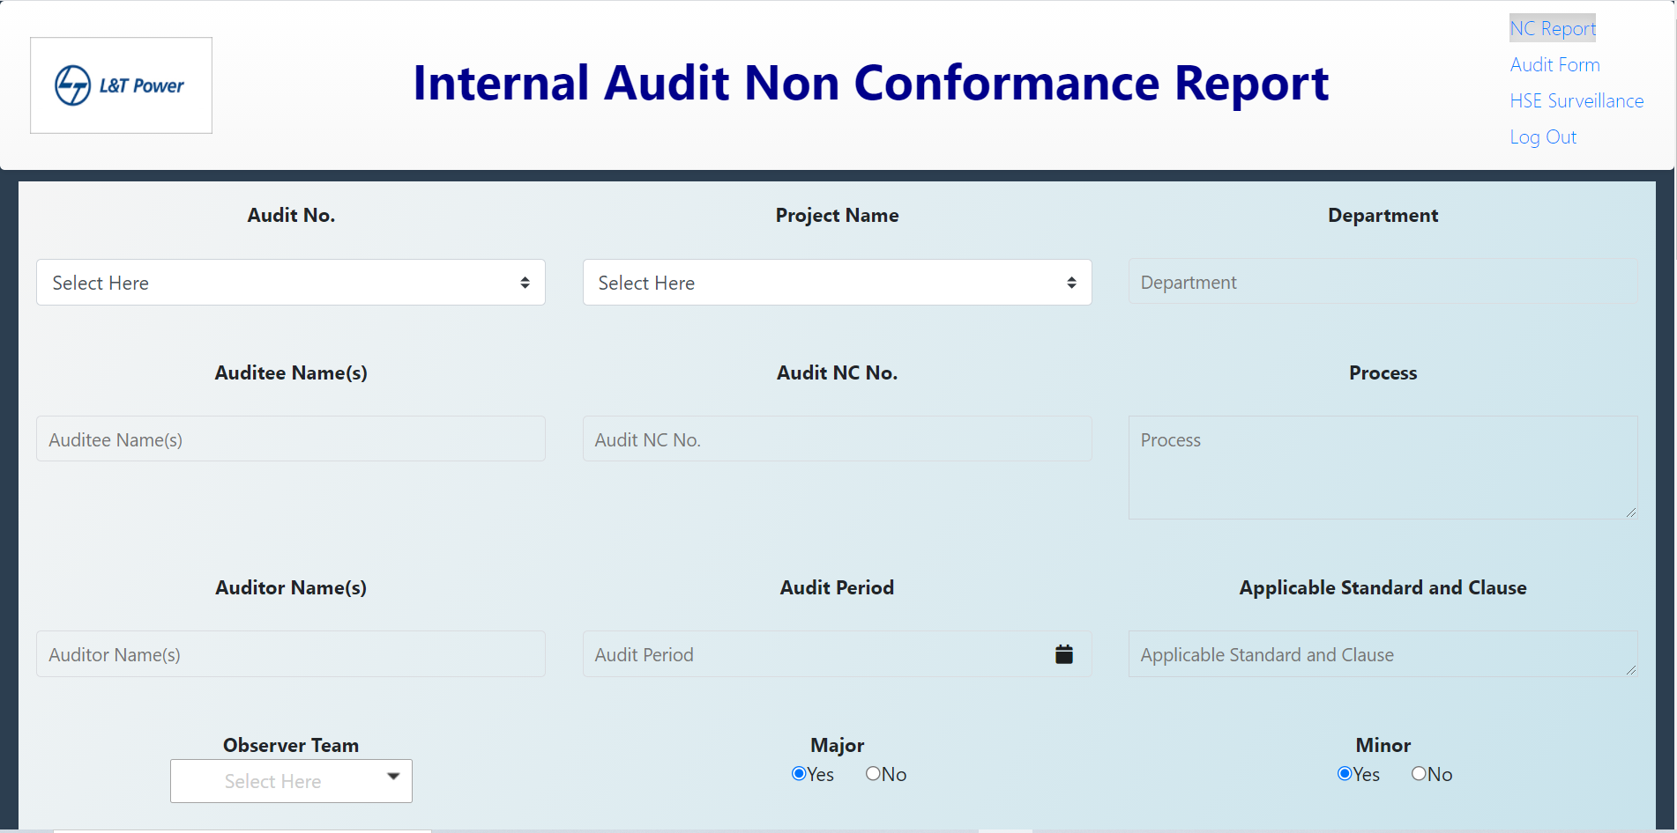

* This Report is filled in 3 parts,

1. Initially while Audit Report is being created, the Auditor fills the report till the proposed date field .
2. After rejection by Observer team, the Auditee fills the next portion of form till the evidence section, above clearance report section.
3. When Auditee submits this above report, Auditor fills the clearance report section.

* **Contents of NC Report**

1. **Audit No.**

* Audit No. is generated on submission of Audit Form[PART-A], and it consists of Sitename/Year of Audit/ID.
* On selection of this, Project Name dropdown is automatically populated.
* This is a required field and is filled by the Auditor.



1. **Project Name**

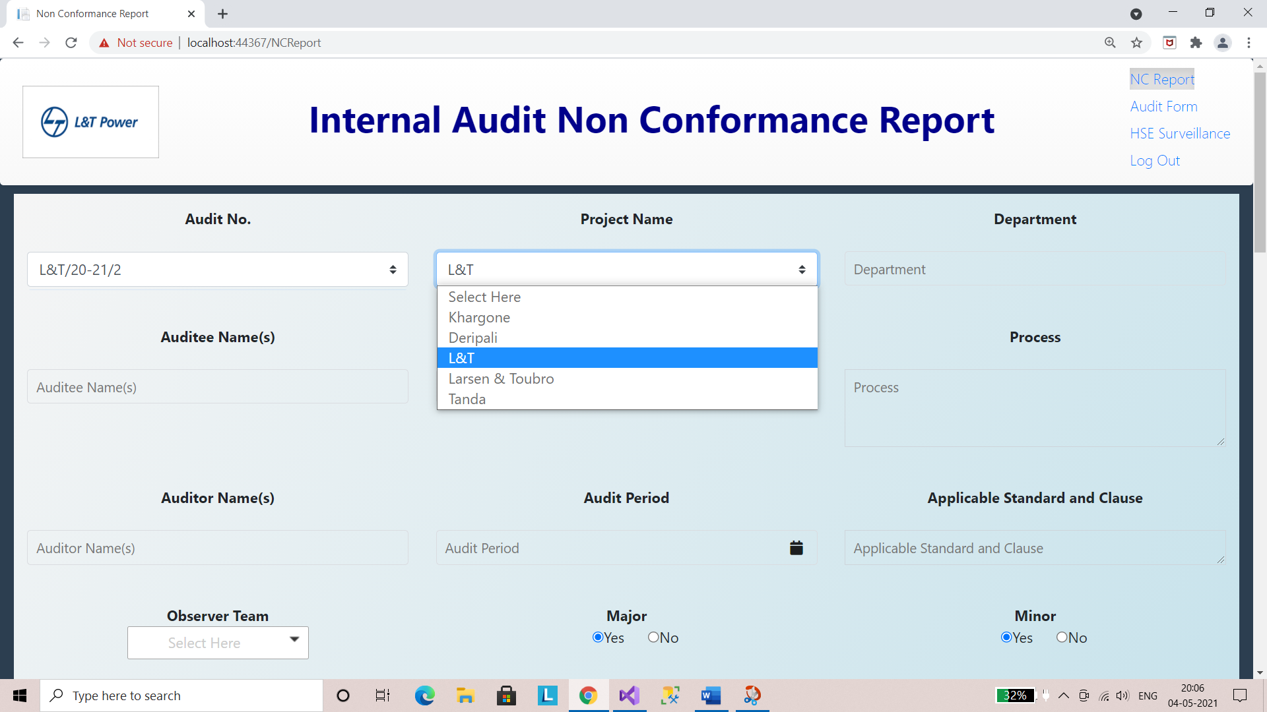

* Project Name dropdown is automatically filled on selection of Audit No. and other options are disabled.
* This field is filled by the Auditor.

1. **Department**

* Enter the name of department here in this field.
* This is a mandatory field and is filled by the Auditor.

1. **Auditee Name(s)**

* The name of Auditee is filled in here.
* This is also a necessary field and is filled by the Auditor.

1. **Audit NC No.**

* Here, the Audit Non-Conformance Number is inserted.
* This is also a necessary field and is filled by the Auditor.

1. **Process**

* In this field, the process is recorded.
* It is a mandatory field and is filled by the Auditor.

1. **Auditor Name(s)**

* The name of Auditor is filled in here.
* This is a necessary field and is filled by the Auditor.

1. **Audit Period**

* Audit Date is inputted in this field. The default Date is set to current date.
* This is also a necessary field and is filled by the Auditor.

1. **Applicable Standard and Clause**

* Applicable Standard and Clause are entered in this field.
* This is also a necessary field and is filled by the Auditor.

1. **Observer Team**

* The Observer Team is selected here from the multi select dropdown list.
* This is also a necessary field and is filled by the Auditor.

1. **Major**

* This is a Radio Button to choose whether NC is Major or not.
* This field is filled by the Auditor.

1. **Minor**

* This is a Radio Button to choose whether NC is Minor or not.
* This field is filled by the Auditor.

1. **Requirement of Audited Standard**

* The requirement of audited standard is filled in here.
* This field is filled by the Auditor and is a mandatory field.

1. **Observed Non-Conformity**

* The observed NC is written here.
* This field is filled by the Auditor and is a mandatory field.

1. **The objective evidence on which the non-conformity is based.**

* Enter the evidence here in this field.
* This field is filled by the Auditor and is a mandatory field.

1. **Root Cause Analysis and Corrective Action**
2. **Proposed Completion Date**

* The proposed completion date is picked in here from the date picker.
* The default Date is set to current date.
* This field is filled by the Auditor.

1. **Actual Completion Date**

* The actual completion date is filled in here from the date picker.
* The default Date is set to current date.
* This field is filled by the Auditee.

1. **Responsible Person**

* Write the Responsible person’s name here.
* This field is filled by the Auditee.

1. **Root Cause Analysis and Corrective Action Response**
2. **Correction (for what needs immediate correction)**

* The corrections are mentioned here in this field.
* This field is filled by the Auditee.

1. **Root Cause Analysis**

* Root Cause Analysis is filled by the Auditee.

1. **Corrective Action Response**

* Here, the Auditee is supposed to fill in the Corrective Action Response.

1. **The** **evidence to support the resolution of nonconformities shall be recorded**

* The evidence to support the resolution of nonconformities shall be recorded by the Auditee in this text area.

1. **Clearance Report**

* This Report is filled by the Auditor only after Auditee has submitted the above section of this report.

1. **Corrective Action Accepted**

* This is a Radio Button to choose whether Corrective Action is accepted or not.

1. **Non-Conformance Downgraded**

* This is a Radio Button to choose whether NC has downgraded or not.

1. **Comments**

* Comments are added here by the Auditor.

1. **Auditor**

* This contains the Auditor Name.

1. **Date**

* Here, the current date is filled in by default.

1. **Submission**

* On successful submission the pop-up appears.
* The page is then redirected to Audit Details page.

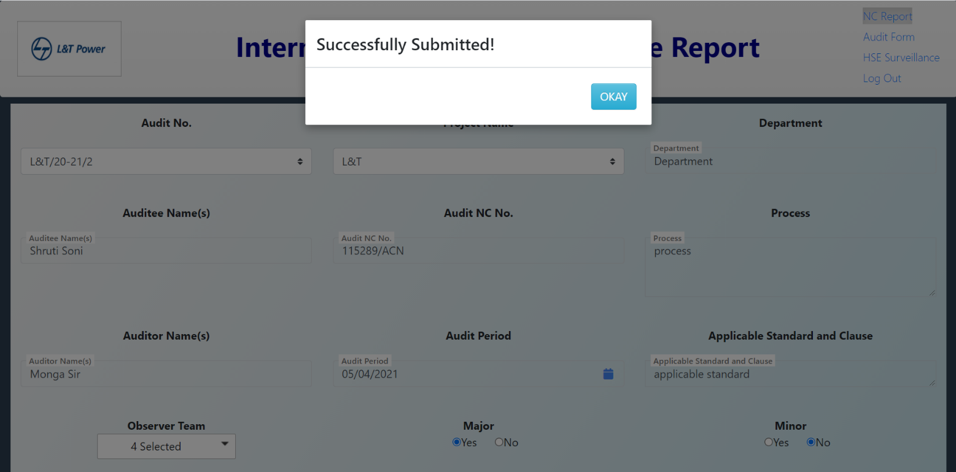

## **Audit Details**

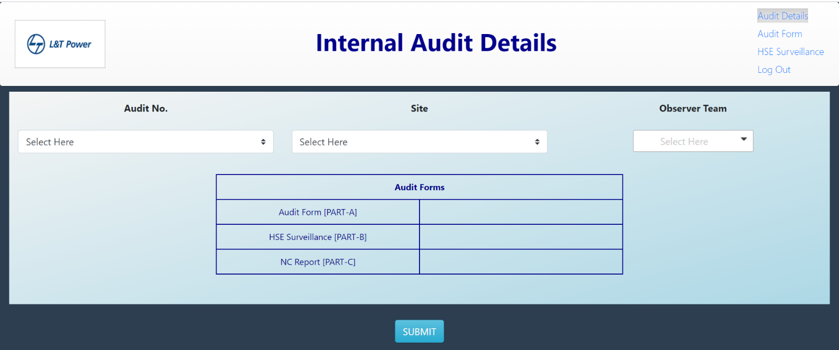

* In this form, as soon as the Audit No. is chosen from the dropdown list, the site is automatically selected and Links to all the above three forms appears.

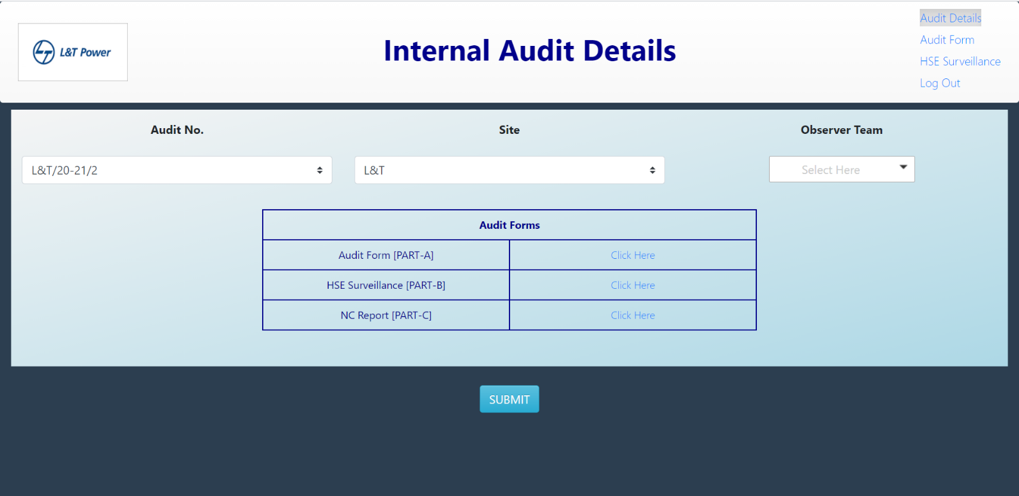

* The Observer team dropdown is populated according to the site name. Select the people needed to be added in the observer team for that particular audit and click submit.
* On submit, an email is sent to the observer team chosen for reviewing the Audit.

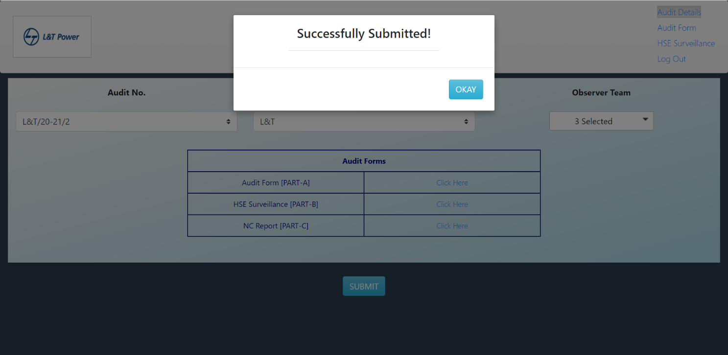

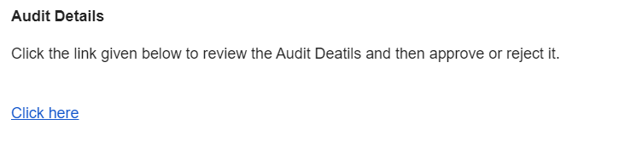

* Email sent to the Observer Team.
* On click of this link, the page is redirected to Audit details page.

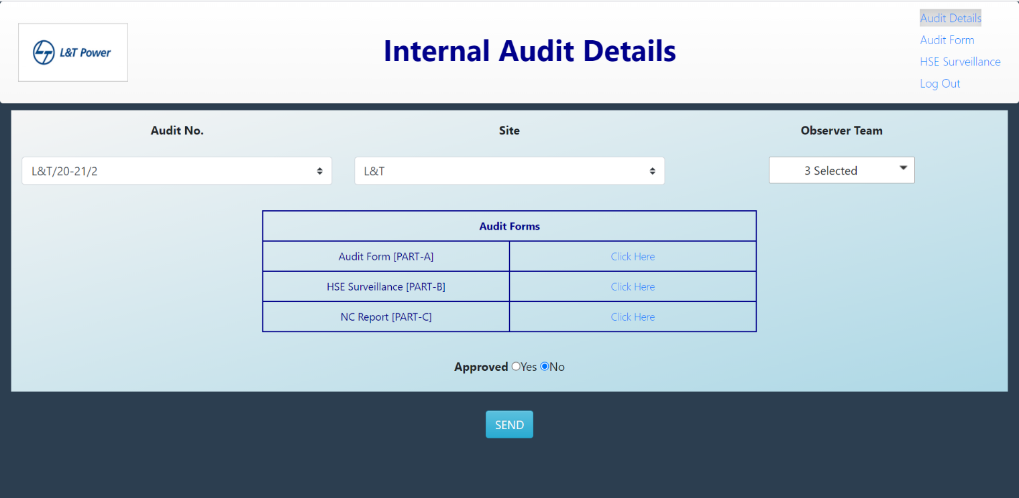

* The observer team, after reviewing the audit details, approves or rejects it.
* On Approval, mail is sent to the Auditor.

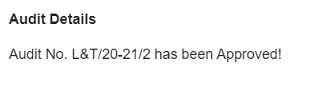

* On Rejection, pop-up appears which asks for selection of Auditee team.
* After selection of Auditee team, click okay.
* On clicking Okay, email is sent to the Auditee team and also to the Observer Team and auditor.

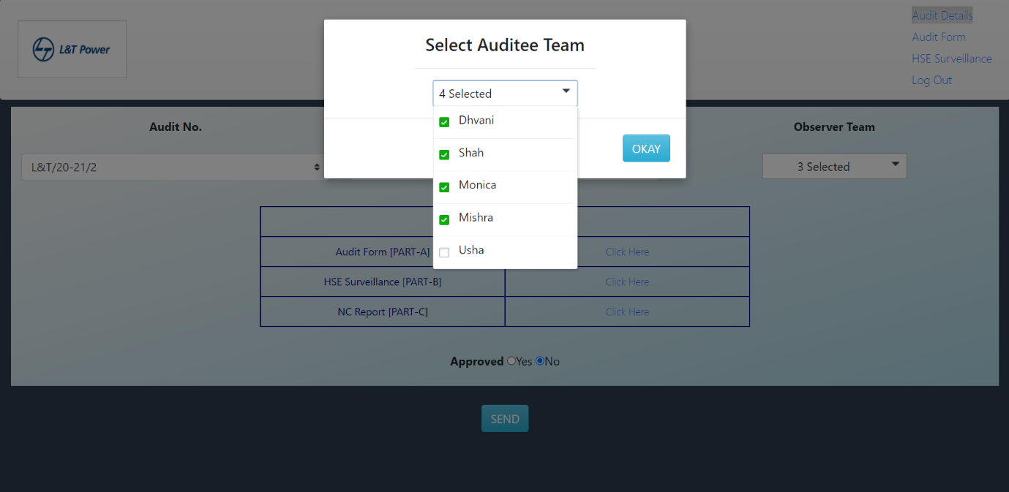

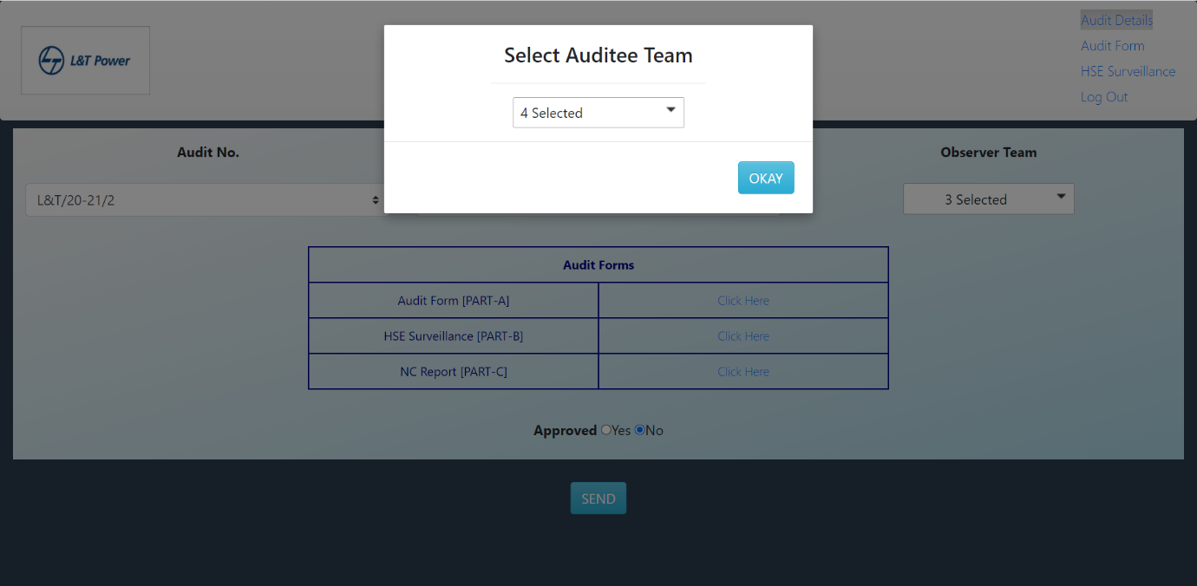

* Mail pic

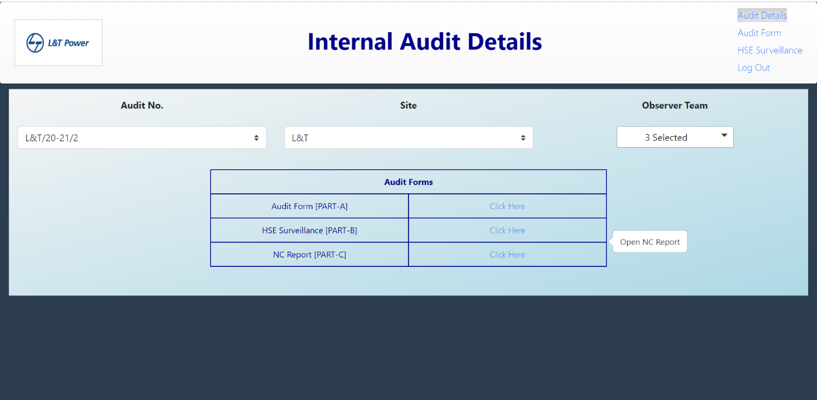

* Auditee then opens the NC Report and fills the second section of it and submits it to the Auditor via email.

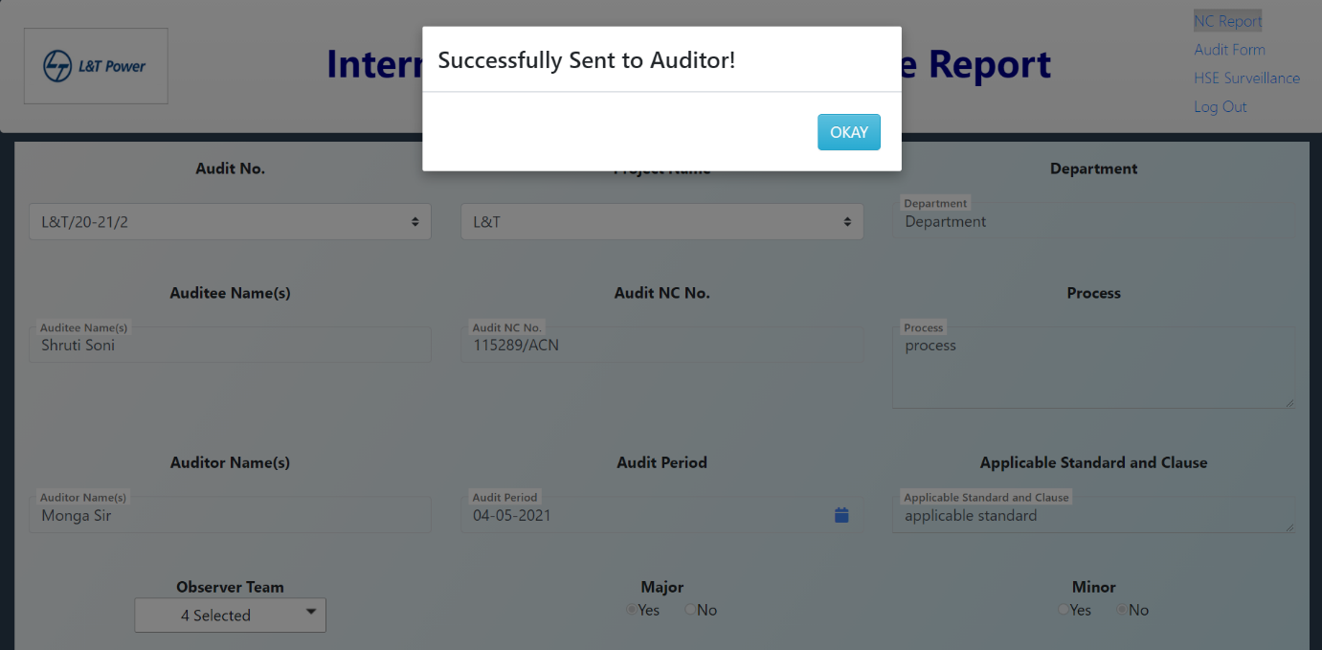

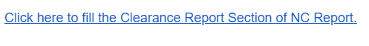

* The Auditor clicks this link and fills the Clearance report section of NC Report.

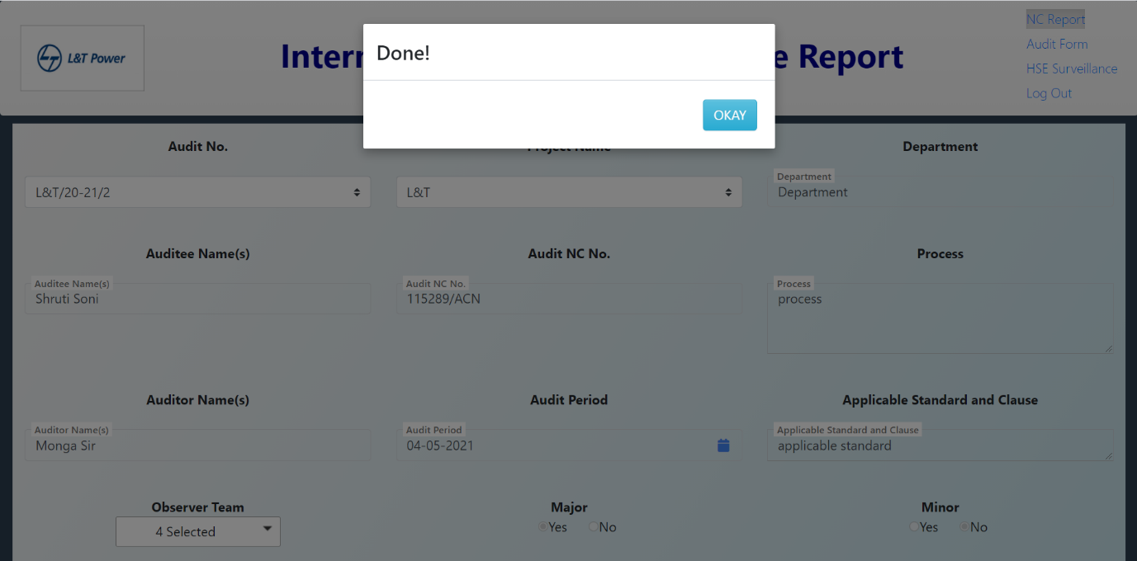

* After this submission, email is sent to the Auditor to review all the audit details.

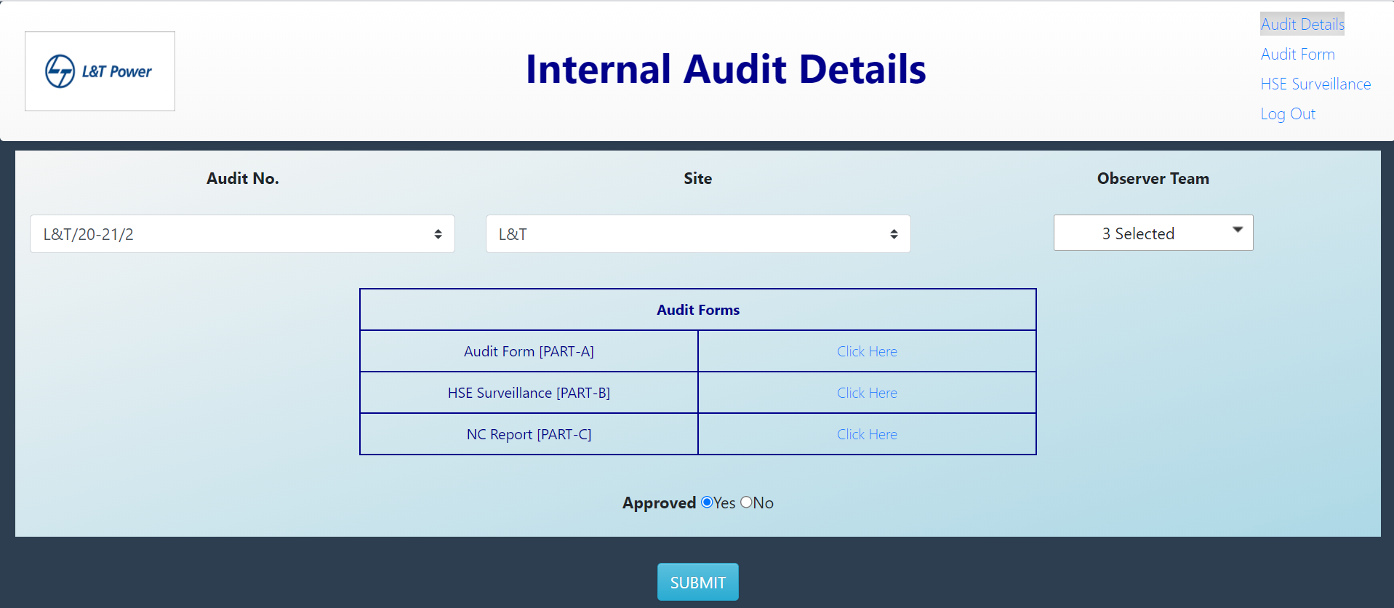

* After reviewing, select whether to approve it or not.

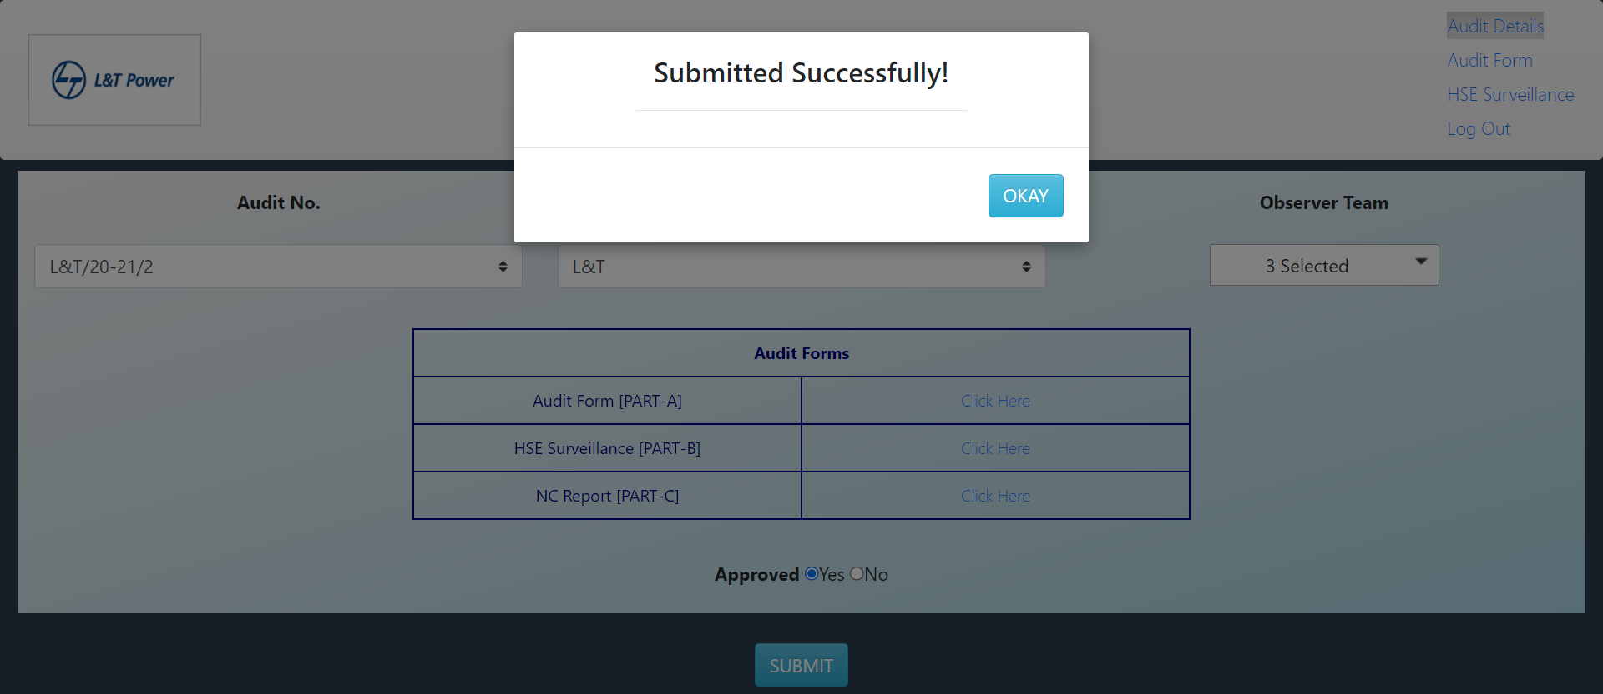

## **Dashboard**

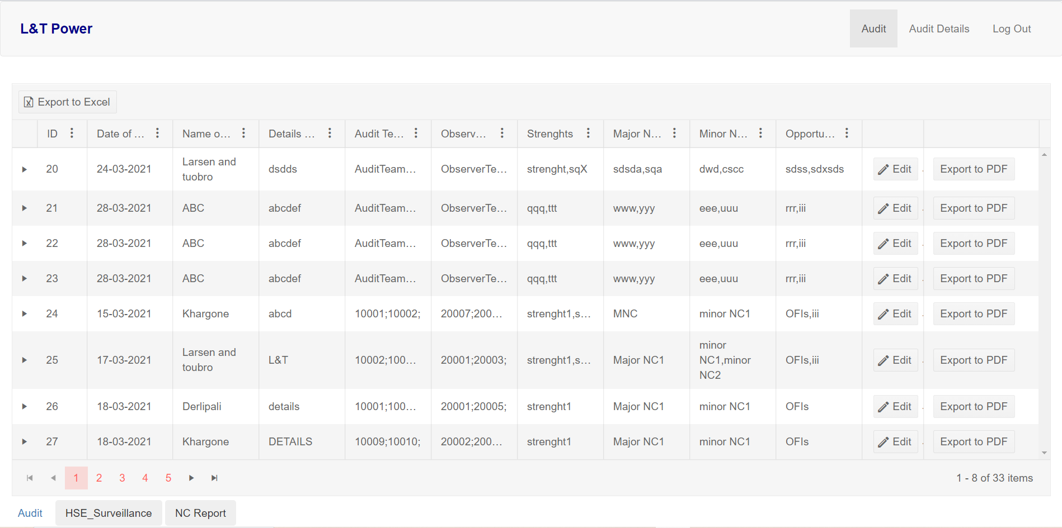

* The Dashboard consists of all the data of Audit. It has 3 tabs, for all three forms.
* For filtering or sorting data, click the  icon at the column where you want to perform sorting or filtering actions.

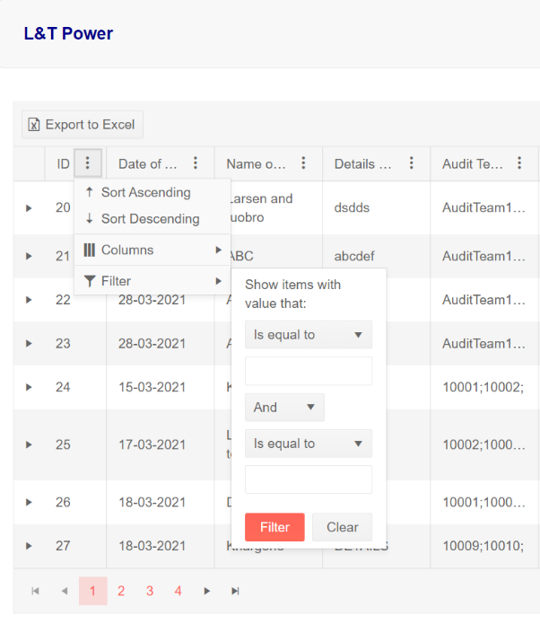

* **Audit Tab**
* All the observations and scores recorded in PART-A form are available on click of the arrow in the very first column as shown below.

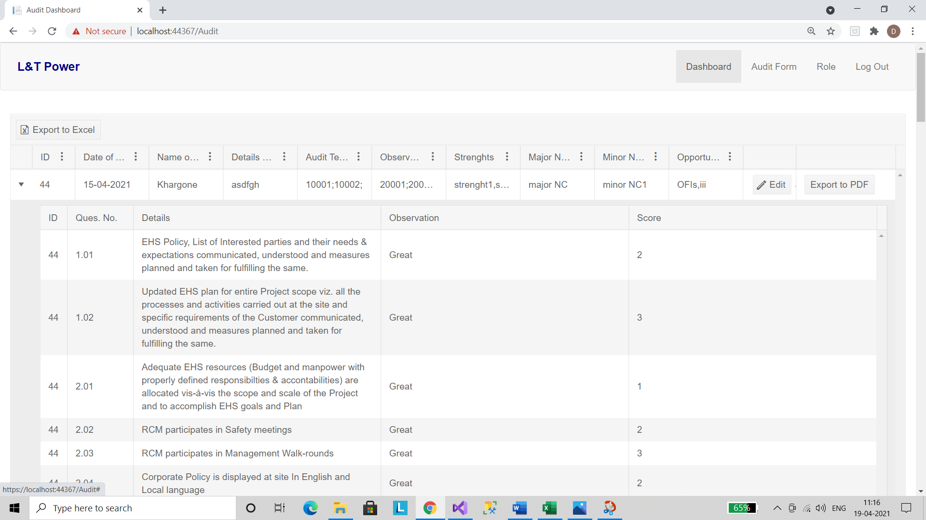

* The other functionalities of this tab include:
* Export to Excel
* Export to PDF
* Editing Details

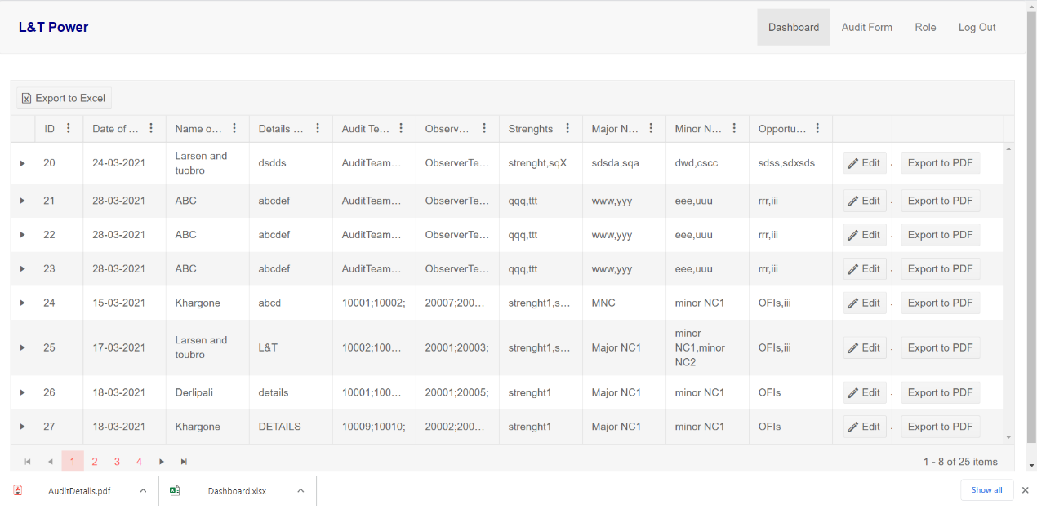

1. **Export to Excel**
   * In the toolbar, click the button ‘Export to Excel’ to get all the data of all the pages of dashboard in Excel Sheet format.
   * On clicking it the excel sheet gets downloaded.

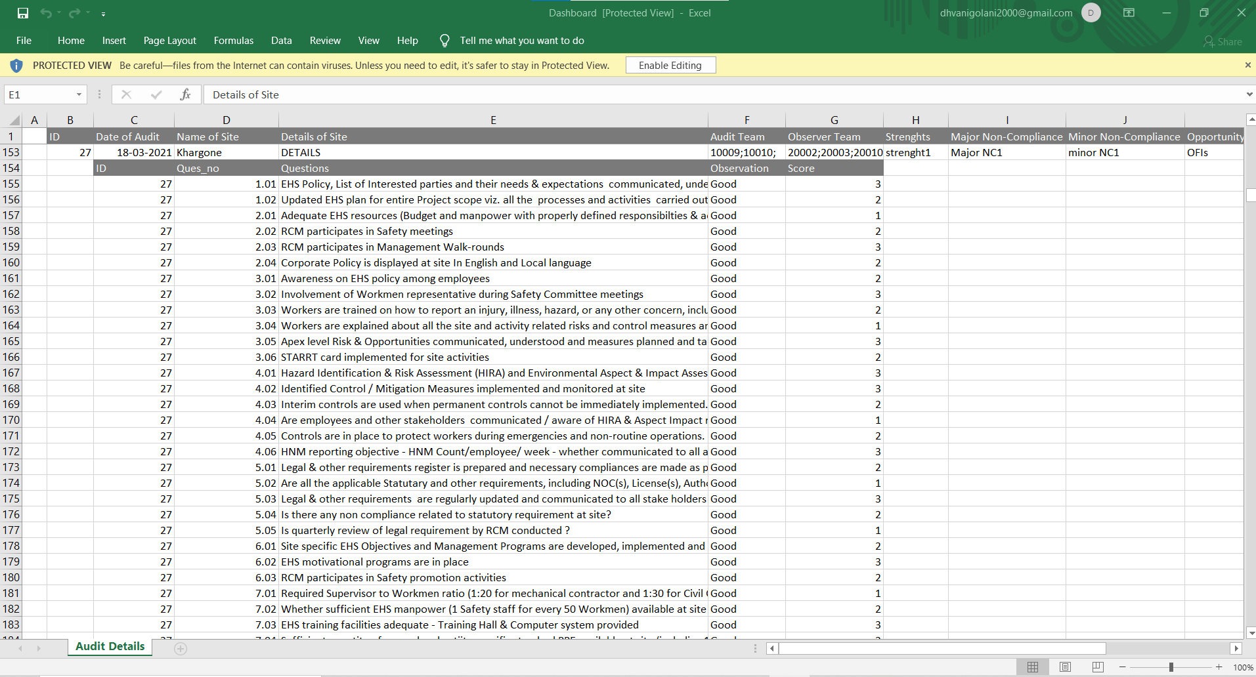

1. **Export to PDF**
   * In every row there’s an option of Export to PDF in the last column.
   * On clicking it the PDF file for that particular audit gets downloaded.

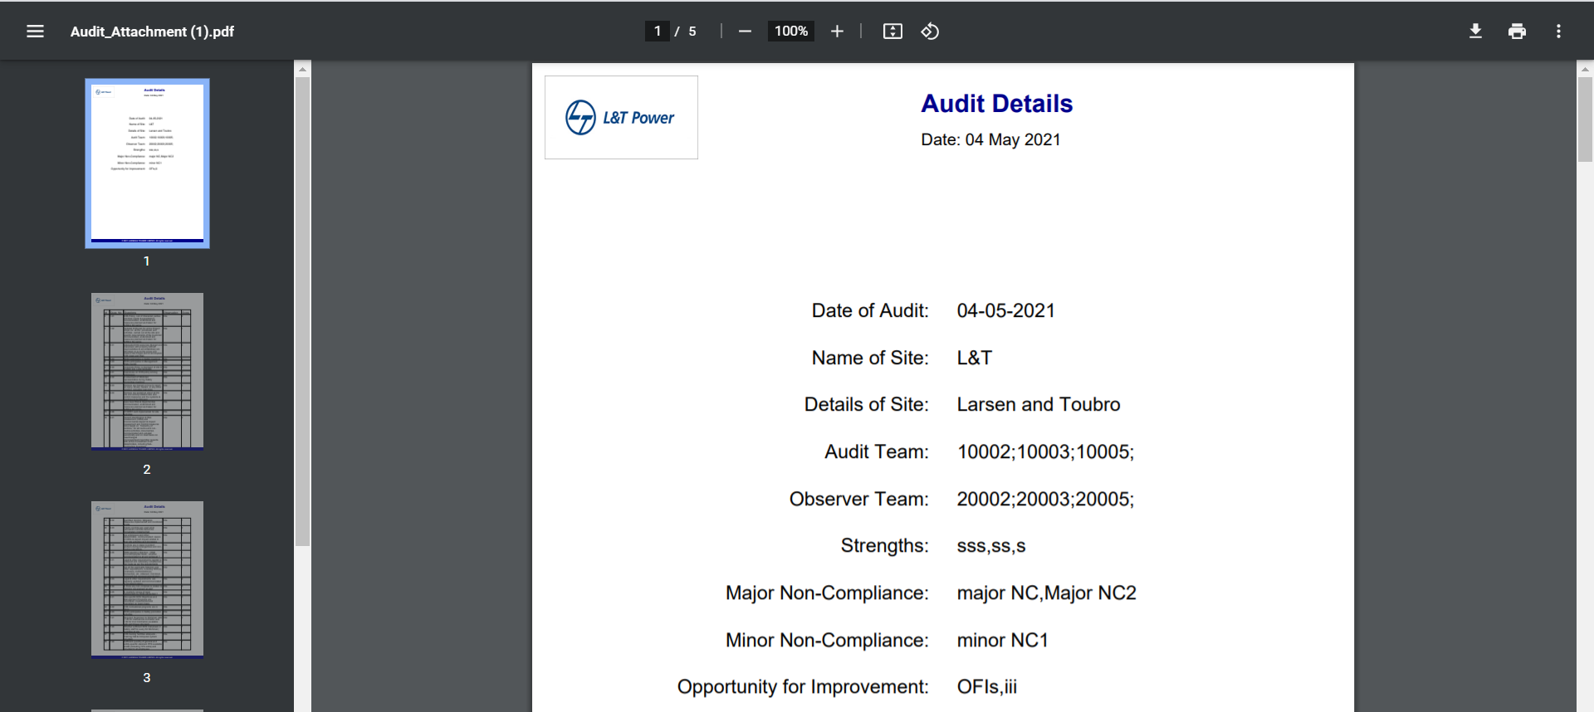

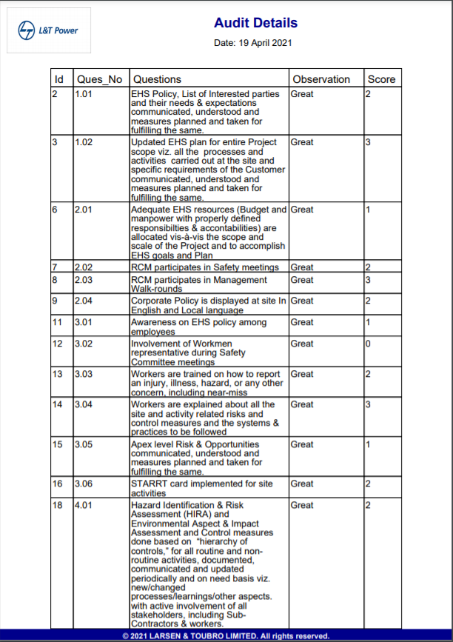

1. **Editing Details**
   * In every row there’s an option of Editing the details.
   * Click on the Edit button and the page gets redirected to the Audit Form with all the previously inserted data; Make the necessary changes and click the Update button at the end of the form and the form gets updated.

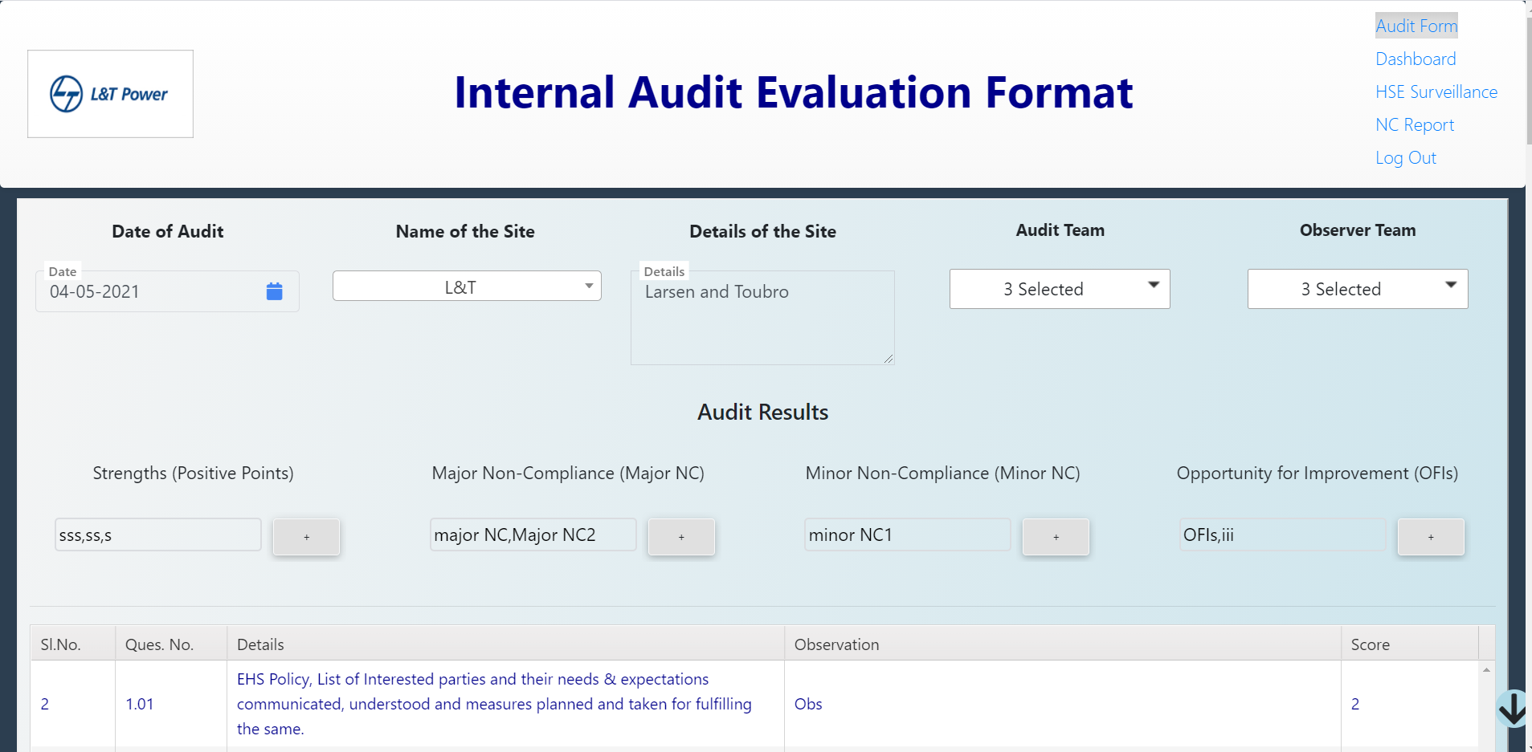

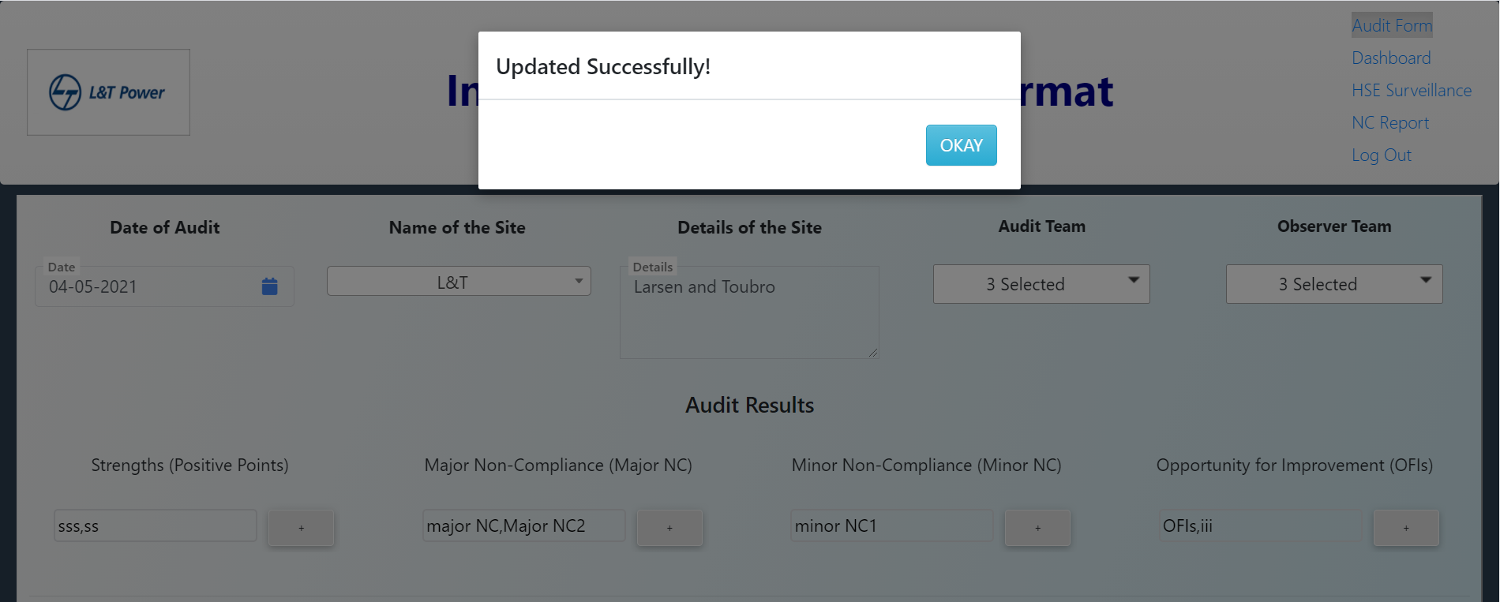

* **HSE Surveillance Tab**

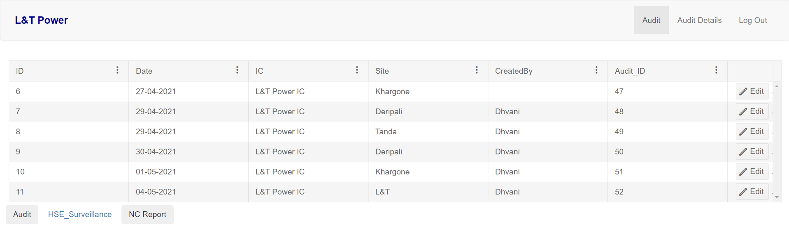

* It contains data of HSE forms with edit functionality.
* On clicking edit in any row, the HSE form filled with data for that selected Id will appear.

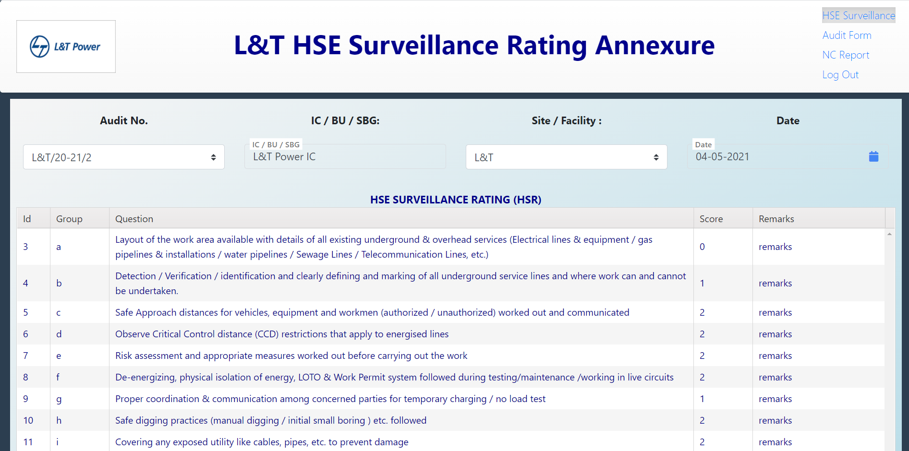

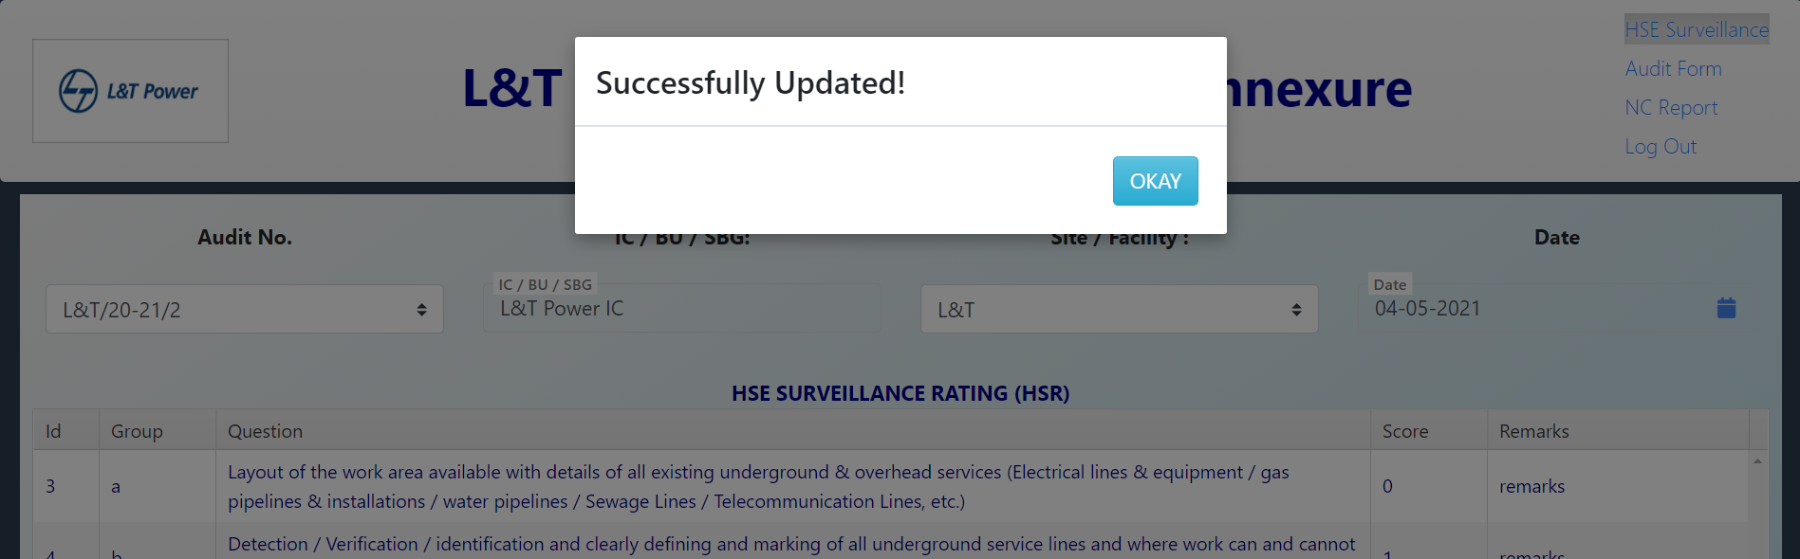

* **NC Report Tab**

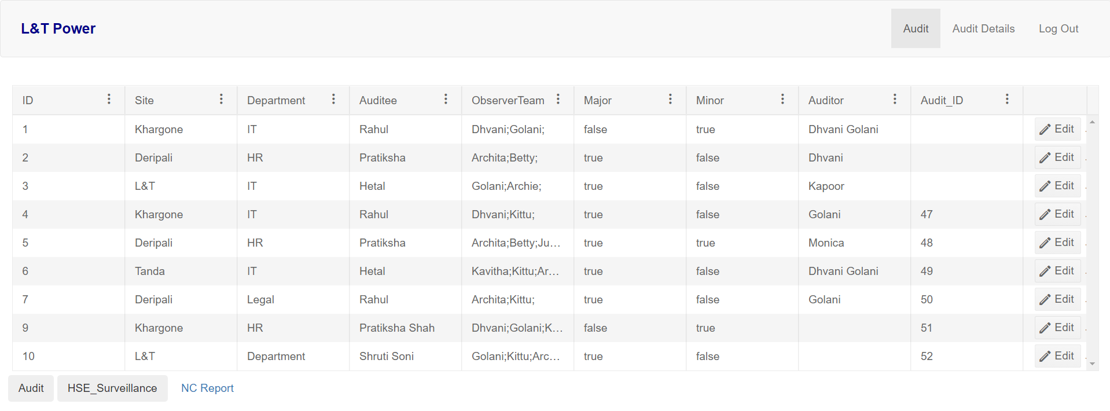

* It contains data of NC Report with edit functionality.
* On clicking edit in any row, the NC Report filled with data for that selected Id will appear.

